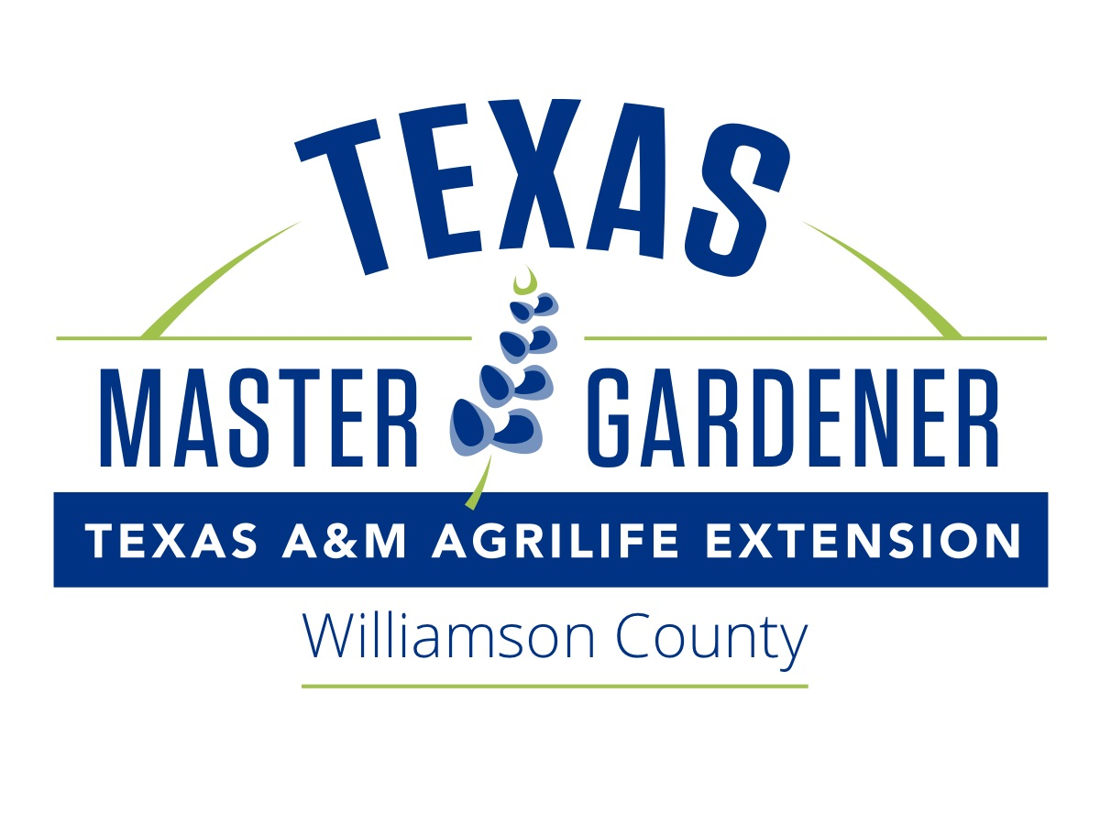

FOR IMMEDIATE RELEASE May 2022

Green Thumbs Up Gardening Program for May 2022:
Irrigation Tune-Up Tips
Do you struggle with setting up a watering schedule for your lawn and plants? The Green Thumbs Up Gardening Program is FREE and open to the public. No registration is required. The topic for May is Irrigation Tune-Up Tips, presented by Master Gardener Steve Craig. This program will give you information about ways to irrigate your lawn and garden easily and efficiently. Green Thumbs Up will be presented at the following locations and times, so you can choose one most convenient to you:

Round Rock Public Library, Meeting Room A, 216 E. Main St. in Round Rock. Thursday, May 5, from 6:30-7:30 pm

Cedar Park Public Library, 550 Discovery Boulevard in Cedar Park. Tuesday, May 10, from 7:00-8:00 pm

Brushy Creek Community Center, Oak Room, 16318 Great Oaks Dr in Round Rock. Wednesday, May 18, from 12:00–1:00 pm

For more information on other events please visit our website at: williamson.agrilife.org
Contact Kate Whitney at klwhitney@ag.tamu.edu or the Extension Office: 512-943-3300..

Sheryl Hays
(512)943-3300
Williamson County Horticulture Admin, and Receptionist
100 Wilco Way, Suite AG201, Georgetown, Texas 78626
Website: https://williamson.agrilife.org/

